OPC UA Connection AXC F 2152-2021 LTS and Visu+ 2.53

# Objective:

This document will provide instructions on how to setup OPC UA communications between PLCnext 2021 and Visu+ 2.53.

## OPC UA Server settings in PLCnext Engineer

Starting from a new project the OPC UA Server has default settings that will need to be modified to work with the Visu+ OPC US Client.

Open the OPC UA properties

Double click on the OPC UA icon in the Plant view of PLCnext Engineer.

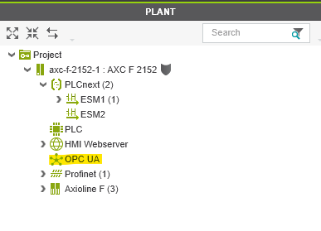

OPC UA Basic settings

Select either **Marked** or **All** for Visibility of variables.

Note* If Marked is selected, OPC must be checked in the variable declaration. See steps below, Declaring Variables as OPC tags

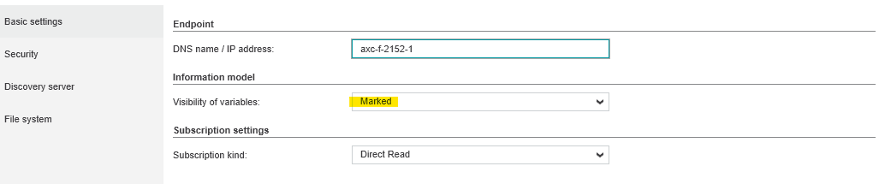

OPC UA Security settings

1. Set Enable basic 256 algorithm to **Yes**
2. Set Enable basic 256 SHA256 algorithm to **Yes**
3. Set Enable AES 128 SHA256 RSA OAEP algorithm to **No**
4. Set Enable AES 256 SHA256 RSA PSS algorithm to **No**
5. **Uncheck** Use the truststore for client authentication
6. **Uncheck** Check application URI against client certificate

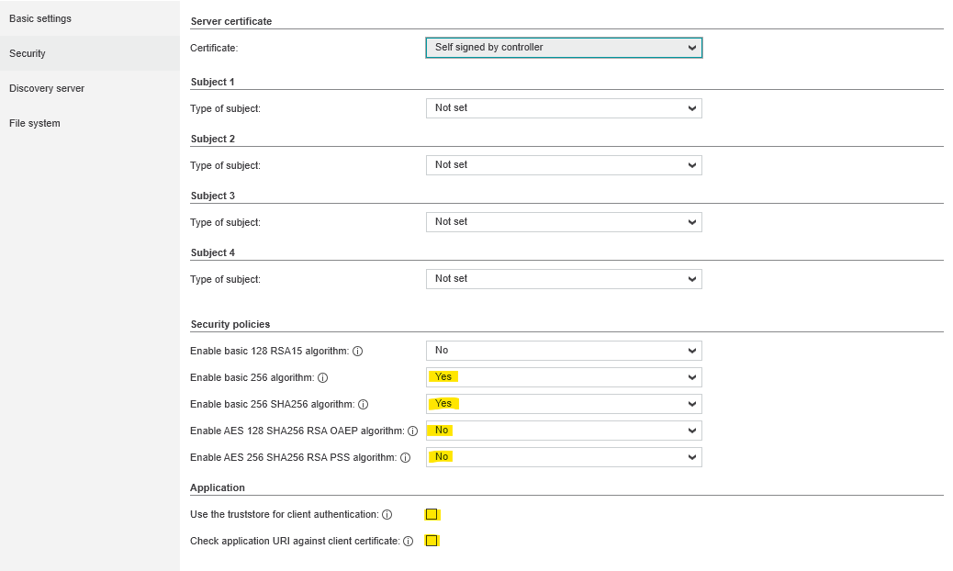

Discovery server and File system settings

Keep to default settings. No changes needed.

Declaring Variables as OPC tags

Global variable declared in PLC Data List.

1. Double click on the **PLC** icon in the Plant view of PLCnext Engineer
2. Select the Data List tab
3. Check **OPC** for all variables you want to be shared with the OPC UA server

Note* If you do not see the OPC column, click the arrow in the Variable (PLC) cell.

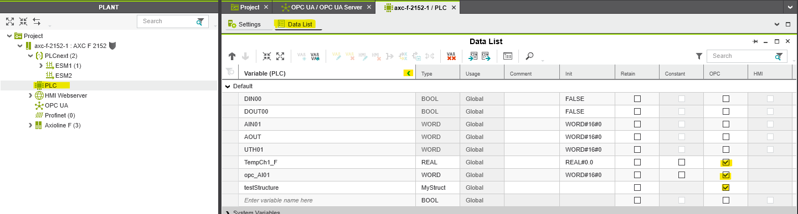

Local variables declared in Program Variables.

1. Open the program in the Project Workspace
2. Select the **Variables** tab
3. Check **OPC** for all variables you want to be shared with the OPC UA server

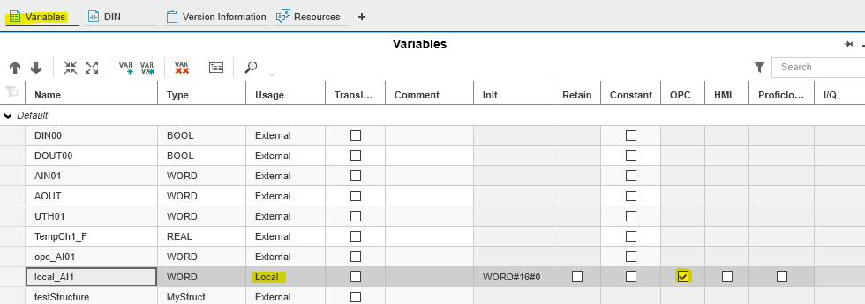

*Write and Start the project to the controller via the Cockpit*

1. Double click on the **axc-f** icon in the Plant view of PLCnext Engineer
2. Select the **Cockpit** tab
3. Choose **Write and Start** **Projec**t from the drop down
4. **Cycle power** on the PLCnext controller to have OPC changes take effect

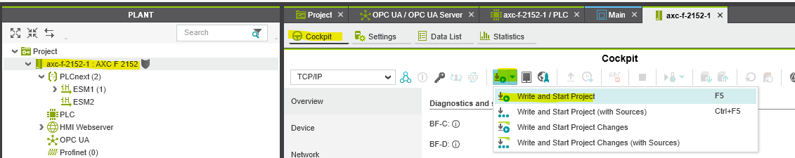

## Adding OPC tags in Visu+

## Starting from a new project in Visu+

Browse OPC UA tags on the PLCnext controller

1. Right click on the **OPC UA Client** in the Project Resources
2. Select **Add New OPC UA Tag…**

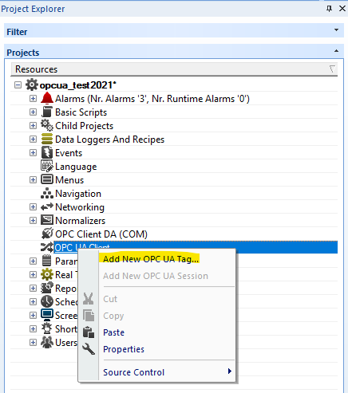

Add a new Endpoint

The Tag Browser will open

1. Enter **opc.tcp://”IP address of controller”:4840** in the Endpoint field
2. Set Security to **SignAndEncrypt**
3. Enter **User Name and Password** for the PLCnext controller
4. Click OK to add Endpoint to the OPC configuration.

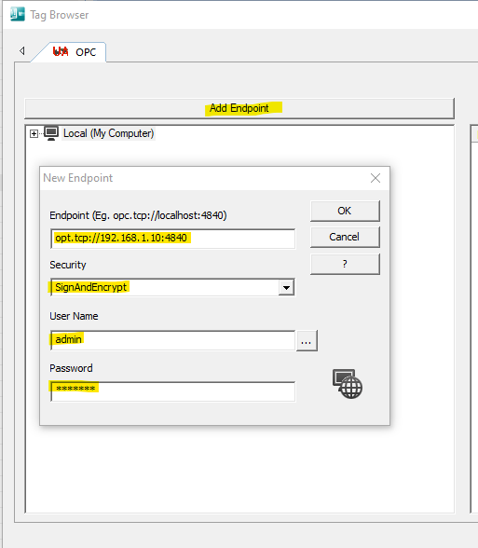

Import tags from new Endpoint

Add Global tags

1. Click on the **+** to expand the OPC tag tree
2. Click the **+** by **PLCnext** select the **Arp.Plc.Eclr** icon to expose the Global tags
3. Select the tags in the right pane and click **OK** to add the tags to your project

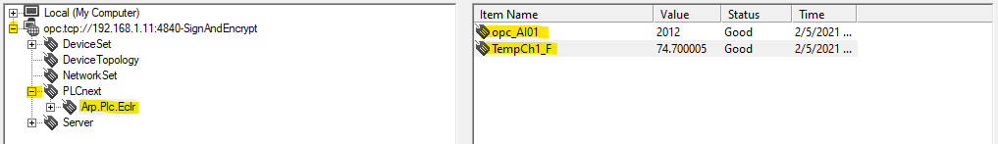

Add Local tags

1. Right click on the **OPC UA Client** in the Project Resources
2. Select **Add New OPC UA Tag…**
3. Click the **+ Arp.Plc.Eclr**
4. Select **Maininstance** to expose the Local tags
5. Select the tags in the right pane and click OK to add the tags to your project

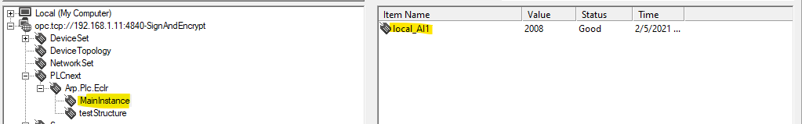

The tags are now available in Variable (Tags) in the Real Time DB

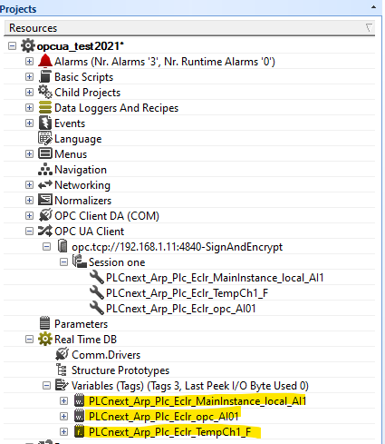

## Editing a Visu+ project that was previously connected to a PLCnext 2020.x controller

The existing OPC UA Endpoint will have to be removed from the project to create the correct OPC UA connection

1. Right click the existing Endoint
2. Select **Cut** from the menu
3. Close the Visu+ project
4. Close Visu+

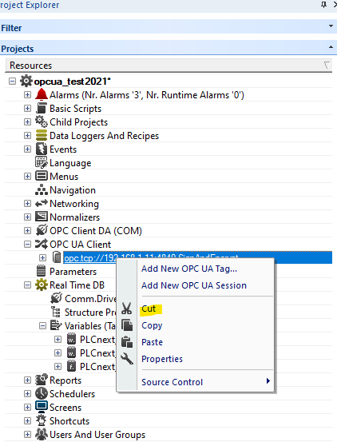

Reopen Visu+ and follow the steps above for adding tags from a new project. You do not have to delete the tags in the Real Time DB. The tags will automatically map with the OPC tags